User Guide

Step by step operation of the widget to keep your story items in sync

the SharpCloud Synchronise items Widget

Contents

Executive Summary 2

Pre-requisites 2

Using the SharpCloud Synchronise Items Widget 3

Step 1: Activate your Account with the Widget 3

Step 2: Select one or more reference stories 4

Step 3: Select a Working story 6

Step 4: Copy Items from the Reference Story to the Working Story 7

Step 5: Check for Changes to Reference or Working Stories 8

Step 6: Re-sync to Update the Items in the Working Story 8

# Executive Summary

The **SharpCloud Synchronise Items Widget** is a tool for copying items between stories, and keeping items in sync if changes are made at a later date.

The widget allows you to copy a set of items (and their relationships to other items in the set) from one or more **reference stories** to a single **working story**. Once these item copies have been created in the working story, the widget lets you re-synchronise the items as required. This allows changes made to items in the reference stories to be pushed to the working story so that the working story remains up to date.

In summary the widget has two main functions:

* **Creating (linked) copies of items** from reference stories in a single working story
* **Re-syncing items between stories** so that all or some of the updates made to items in a reference story are applied to the items in the working story.

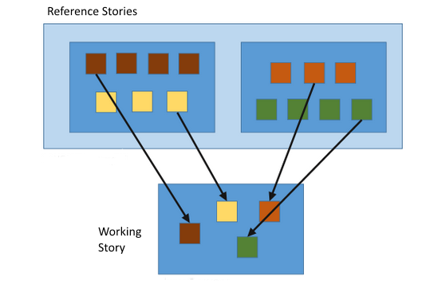

# Pre-requisites

The **SharpCloud Synchronise Items Widget** requires that Microsoft .Net 4.5 or above is installed on the client machine.

# Using the SharpCloud Synchronise Items Widget

## Step 1: Activate your Account with the Widget

1. Run the Widget to open the Credentials screen (below).
2. Enter the SharpCloud server URL, your SharpCloud username and password and click the Save and validate button

* Note: The address in the server box should be the same as the URL you normally use to access SharpCloud

1. You will receive confirmation that your credentials have been validated

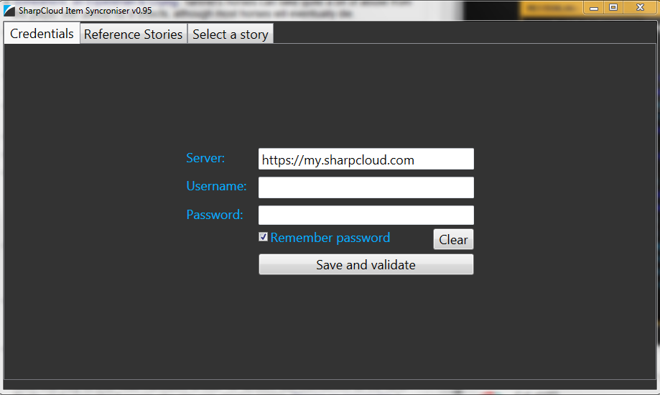

## Step 2: Select one or more reference stories

1. Select the Reference Stories tab

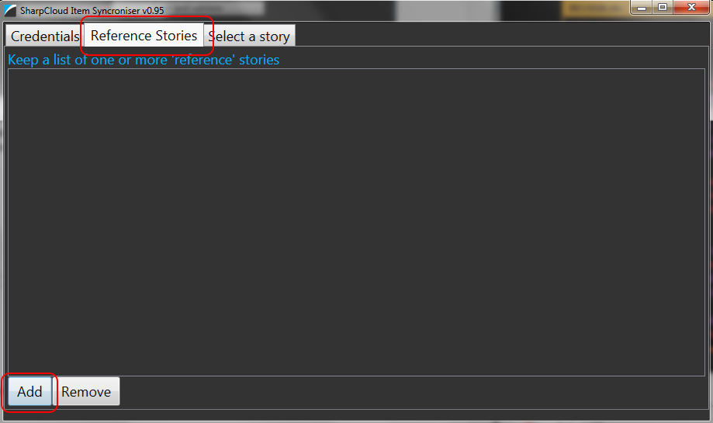

1. Click the Add button. A window opens showing a list of the teams you are a member of.
2. Select the team containing the story(s) you wish to use as the reference story(s). A list of available stories is shown. Check the boxes of each story you wish to use as a reference. Search options are available to help you locate the right teams and stories.

* Note: Repeat this step if you want to select stories from different teams.

1. Click the OK button to use the selected stories as reference stories. The stories you have selected appear in the reference stories list. Below there is only a single story (called Source) that has been selected. You can remove a selected story from the list using the Remove button.

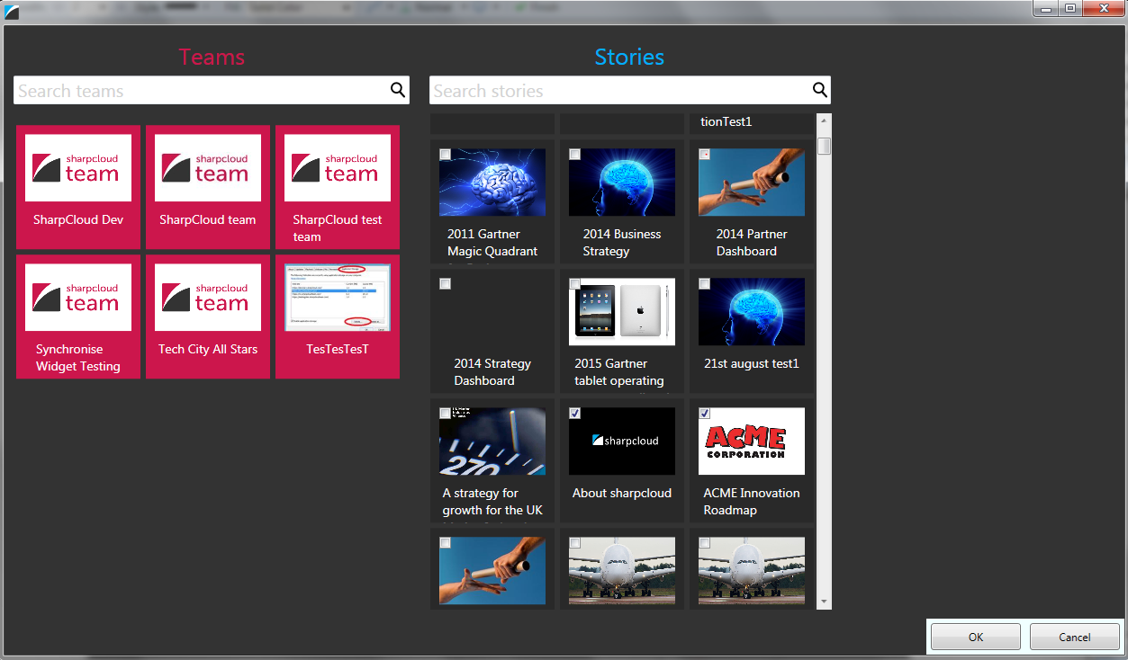

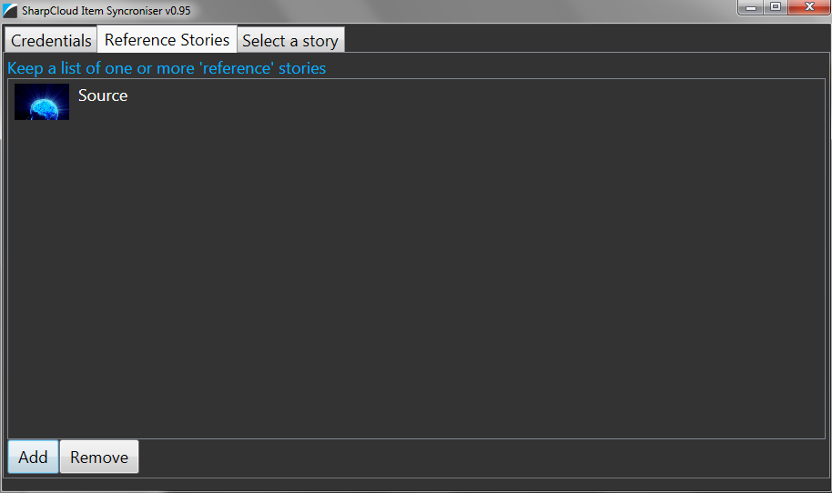

## Step 3: Select a Working story

1. Select the “Select a story” tab.

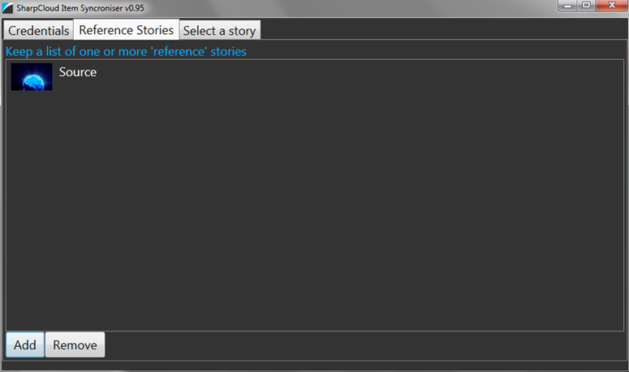

1. Click the “select a new story” button. A window opens showing a list of the teams you are a member of.
2. Select the team containing the story you wish to use as the working story. A list of available stories is shown. Check the box of the story you wish to use as the working story. Search options are available to help you locate the right teams and story.

Notes:

* you can only select and update one working story at a time
* and you must be either an admin or owner of the story
* if you have previously used the widget and selected a story, the “select your last story” button will open the last story used

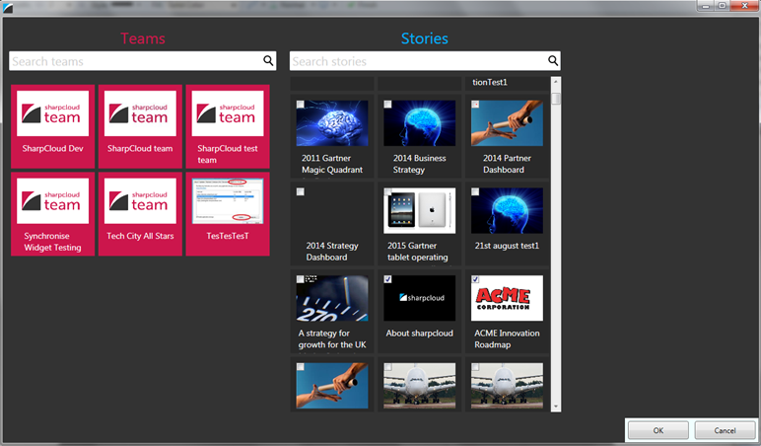

## Step 4: Copy Items from the Reference Story to the Working Story

Once you have selected a working story, two new tabs become available.

1. Select the “Add New Items” to begin copying items from your reference stories to your working story.
2. In the box on the left select the items from your reference stories that you wish to copy to your working story.
3. In the centre box choose which specific content you wish to copy. Note: The choices you make here will apply to all the selected items
4. Press the Add button to copy the selected items from the reference stories to the working story

* Notes: In the box on the right you can see the items that have already been added to the story. The status bar indicates the number of items that have been added to the working story in the most recent operation. You can select additional items and re-click the Add button to copy these additional items to the working story.
* Where the set of items being copied have relationships to other items in the set (and the option to copy relationships has been ticked) these relationships are also copied across to the working story. The status bar again reports the number of relationships that have been copied.

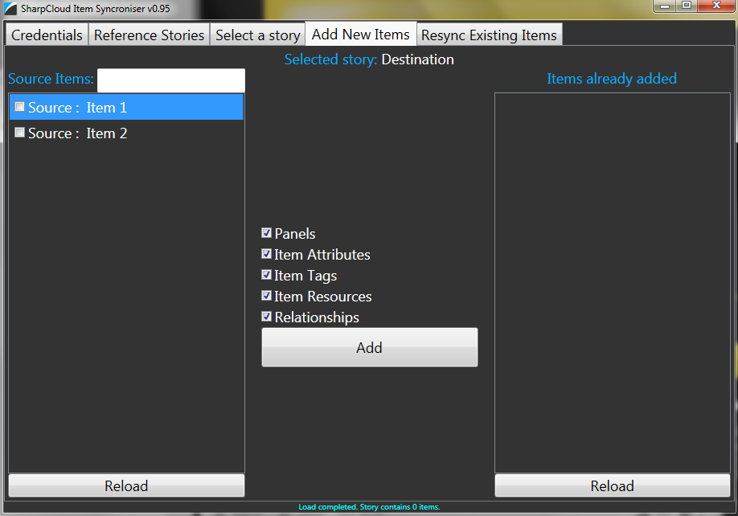

## Step 5: Check for Changes to Reference or Working Stories

Under normal operation SharpCloud stories are modified from time to time as new information is added or updated. Therefore changes to either the reference stories or the working story can lead to the items in these stories becoming out of sync. Therefore each time you use this widget to synchronise between the same reference and working stories you will need to reload the stories in order to identify what has changed since the previous copy operation was run.

1. Click the Reload button on the left to reload the reference stories.
2. Click the Reload button on the right to reload the working stories.

## Step 6: Re-sync to Update the Items in the Working Story

Once the reference and working stories have been reloaded you can review the differences and select which items to re-sync from the reference stories to the working story.

1. Select the “Resync Existing Items” tab. The box on the left contains all of the items in the reference stories that have been updated.
2. Select an item in the box on left, the box on the right will display all of the updates that have been made to that item
3. Use the checkboxes below the box on the right to set which specific content of the item you wish to update.
4. Pressing “Resync Selected” will update all of the selected items in the working story.

